Invoice details Sheet
Business requirements · 8/4/2026

1. What we need
When processing an invoice, staff need to be able to specify which supplier should receive payment and attach a note to accompany that payment — and have both pieces of information travel with the invoice so the supplier receives them automatically.

2. How this works today, and afterwards

Today
Today, there is no dedicated place on the invoice screen to record the intended payment recipient or to leave a message for the supplier. Staff likely communicate this information separately — by email, phone, or a manual note passed to accounts payable — meaning the instruction can arrive late, get lost, or be keyed again by someone else. There is no guarantee the supplier sees the note at the time of payment.

Once this is in place
When an invoice is being processed, the person handling it can type the intended payment recipient directly on the invoice screen alongside any message they need the supplier to receive. Once both are entered, they press Save and the information is automatically included as part of the payment that goes to the supplier — no separate email, no follow-up call, no re-keying.

3. Why it is worth doing
Supplier payment instructions and messages are currently handled outside the invoice itself, creating a gap between what the business intends and what the supplier actually receives. Bringing this information onto the invoice and sending it automatically removes a manual handoff that is a known source of delay and error.

What we gain
- Supplier receives the correct payment recipient detail and any accompanying message at the point of payment, reducing queries and disputes after the fact.
- Accounts payable staff no longer need to chase or separately communicate payment instructions, freeing time spent on follow-up.
- The invoice record becomes the single source of truth for payment intent, reducing the risk of instructions being missed or applied to the wrong payment.
- Fewer back-and-forth queries from suppliers about where payment is going or what it relates to, which shortens resolution time at month end.

If we do nothing
- Payment instructions continue to travel outside the invoice, remaining vulnerable to being missed, misapplied, or delayed.
- Suppliers continue to receive payments without accompanying context, leading to ongoing queries that consume accounts payable time.
- There is no audit trail on the invoice itself for who a payment was directed to or what message accompanied it, complicating dispute resolution.

4. What you will see
Only what is being added or changed. Everything else on these screens stays as it is today.

Invoice Screen 1
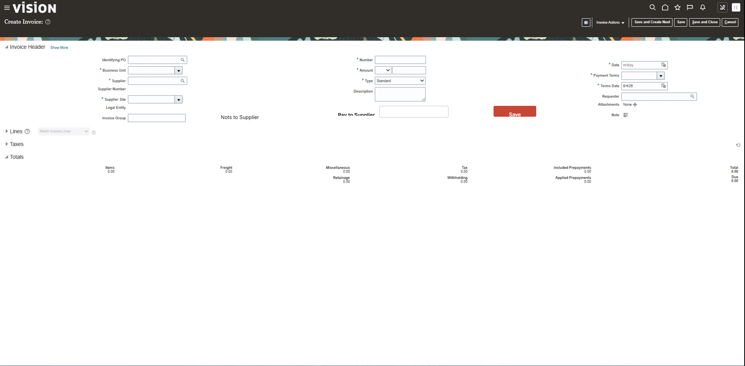

New on this screen
- Pay to Supplier — a box to type into.
- Save — a button to press.
Nots to Supplier

5. Who this affects
- Accounts payable team — they gain a place to record payment recipient and supplier messages directly on the invoice rather than handling these through separate channels.
- Suppliers — they receive payment instructions and notes automatically alongside the payment rather than waiting for a separate communication.
- Finance lead — invoice records now carry a more complete audit trail of payment intent, supporting reconciliation and query resolution.

6. How we will know it worked
- Reduction in the number of supplier queries received after payment relating to recipient details or missing remittance notes — agree a baseline before go-live.
- Accounts payable team confirms they no longer need to send separate communications to suppliers to convey information that was previously off-system — measure time saved per invoice cycle.
- All invoices where a payment recipient or note is relevant have that information recorded and confirmed as received by the supplier.

7. Still to decide
- The consultant's note describes three new additions — Pay to Supplier, Notes to Supplier, and a Save action — but the screen as built shows only one entry box (Pay to Supplier) and a label that reads 'Nots to Supplier' with no corresponding entry box behind it. The business needs to confirm: is Notes to Supplier meant to be a free-form message box like Pay to Supplier, or something else? And is the spelling 'Nots to Supplier' on screen a typographic error that should read 'Notes to Supplier' before this goes live?
- Pay to Supplier is currently set up so that it does not have to be filled in. The business needs to decide: should it be possible to save and send an invoice without specifying a payment recipient, or should that always be required before the invoice can proceed?
- The business needs to confirm exactly what information is sent to the supplier as part of the invoice payment — specifically, whether both the payment recipient name and the notes travel to the supplier, and in what format the supplier receives them (for example, on a remittance advice, within an automated message, or another method).
- The business needs to agree who is permitted to fill in or change the Pay to Supplier and Notes to Supplier entries — any member of accounts payable, or only certain authorised roles?

The written sections were drafted by AI from the screens and notes. Review before circulating. The screens and the list of what is new come directly from the mockup.

