Billing System Evaluation – General Requirements
Functional specification · 8/9/2026
5 screens, 20 new fields, 18 actions.

1. Background
The organisation bills across multiple legal entities and currencies, with integrations spanning CRM, CPQ, usage, tax and payment systems. The evaluation requires Oracle Fusion to serve as the single system of record for all billing, entity management, access control and external connectivity. These screens define the foundational configuration layer on which that record will be built.

How this runs today
Legal entities, currencies and customer records are managed in separate tools or spreadsheets, requiring manual reconciliation and producing duplicate records across organisations. FX conversion is handled outside the core system, approval and access controls are informal, and external system connections rely on custom point-to-point pipelines that break when upstream systems change. Invoice lifecycle events — adjustments, cancellations, payments — are tracked in disparate places, creating audit gaps and delayed period close.

How it runs once built
Administrators define legal entities, business units and intercompany billing flags in one place; the same configuration drives currency setup, role assignment and integration connectivity. Invoices are created, approved, issued, adjusted and paid within a single record that carries legal entity and currency context inherited from that setup. Finance teams stop maintaining parallel spreadsheets for FX, stop manually granting access, and stop chasing invoice status across systems.

2. Screens

2.1 Manage Legal Entities / Subsidiaries
New page — no existing screen.
Defines the legal entities and business units available across the billing platform, and flags which are enabled for intercompany transactions.
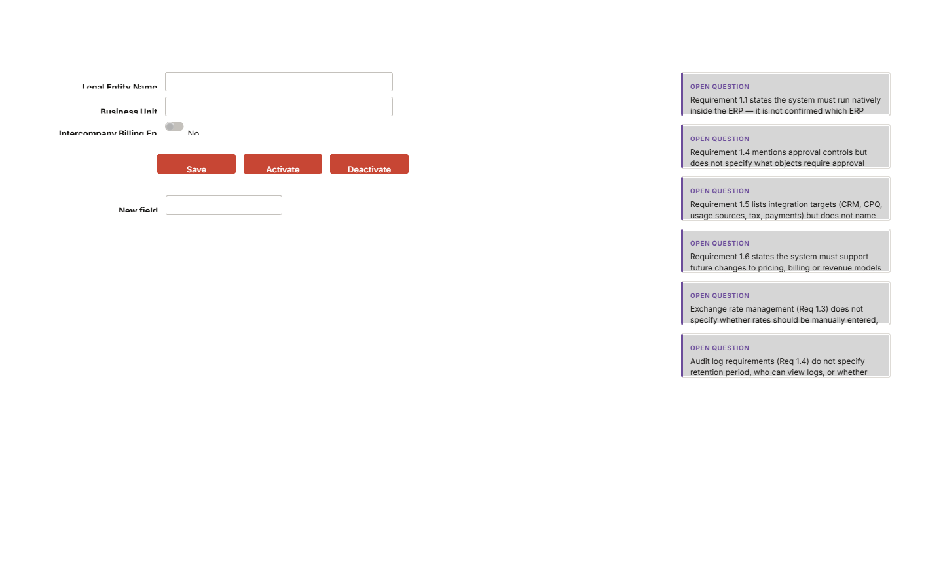

Fields
Field | Type | Required | Values / default | Reference
Legal Entity Name | Free text | Yes | — | manage.legal_entity_name
Business Unit | Free text | No | — | manage.business_unit
Intercompany Billing Enabled | Yes / No | No | — | manage.intercompany_billing_enabled
New field | Free text | No | — | manage.new_field

Actions
- Save
- Activate
- Deactivate

Behaviour
- Legal Entity Name is mandatory on save; the system must reject save if the field is empty.
- Business Unit is optional; if left blank the record saves without a business unit association, but downstream behaviour when no business unit is assigned must be defined.
- Intercompany Billing Enabled defaults to No; changing to Yes must trigger whatever configuration is required to permit intercompany transaction generation — that configuration path must be confirmed.
- Activate sets the entity to an active state available for selection on invoices and other transactions; Deactivate removes it from selection lists but must not delete or alter existing records referencing it.
- The unnamed 'New field' will block build until its label, data type, mandatory status and purpose are confirmed — it should not be built as a generic free-text field without that definition.
- On save, the system must check for a duplicate Legal Entity Name and present an inline error if one exists.

2.2 Manage Currencies
New page — no existing screen.
Maintains the list of active currencies, their exchange rates and the dates from which each rate applies.
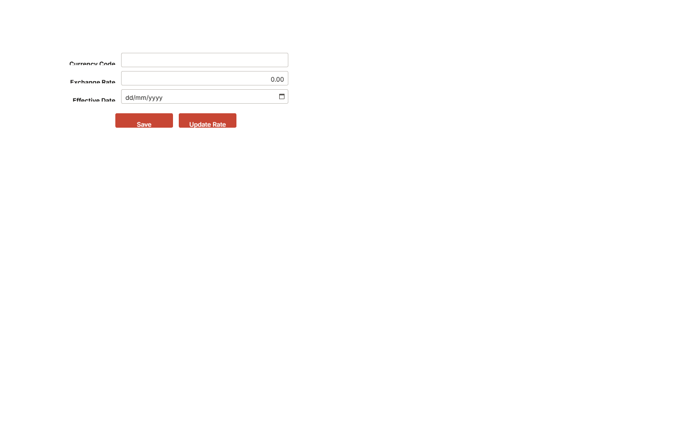

Fields
Field | Type | Required | Values / default | Reference
Currency Code | Free text | Yes | — | manage.currency_code
Exchange Rate | Number | Yes | — | manage.exchange_rate
Effective Date | Date | Yes | — | manage.effective_date

Actions
- Save
- Update Rate

Behaviour
- All three fields — Currency Code, Exchange Rate and Effective Date — are mandatory; the system must block save if any is absent.
- Currency Code should be validated against the platform's supported ISO currency list; an unrecognised code must produce an inline error rather than saving silently.
- Update Rate must create a new rate record dated from the new Effective Date, leaving prior rate records intact so that transactions on earlier dates continue to resolve at the rate that applied then.
- The screen must display at minimum the current active rate and its effective date; whether full rate history is visible inline or via a sub-list must be decided.
- Save on a new currency record makes it available for selection in Manage Invoices and any other currency-referencing screen.

2.3 Manage Roles and Permissions
New page — no existing screen.
Defines named roles, their permission level across billing objects, and whether activity under that role is captured in the audit log.
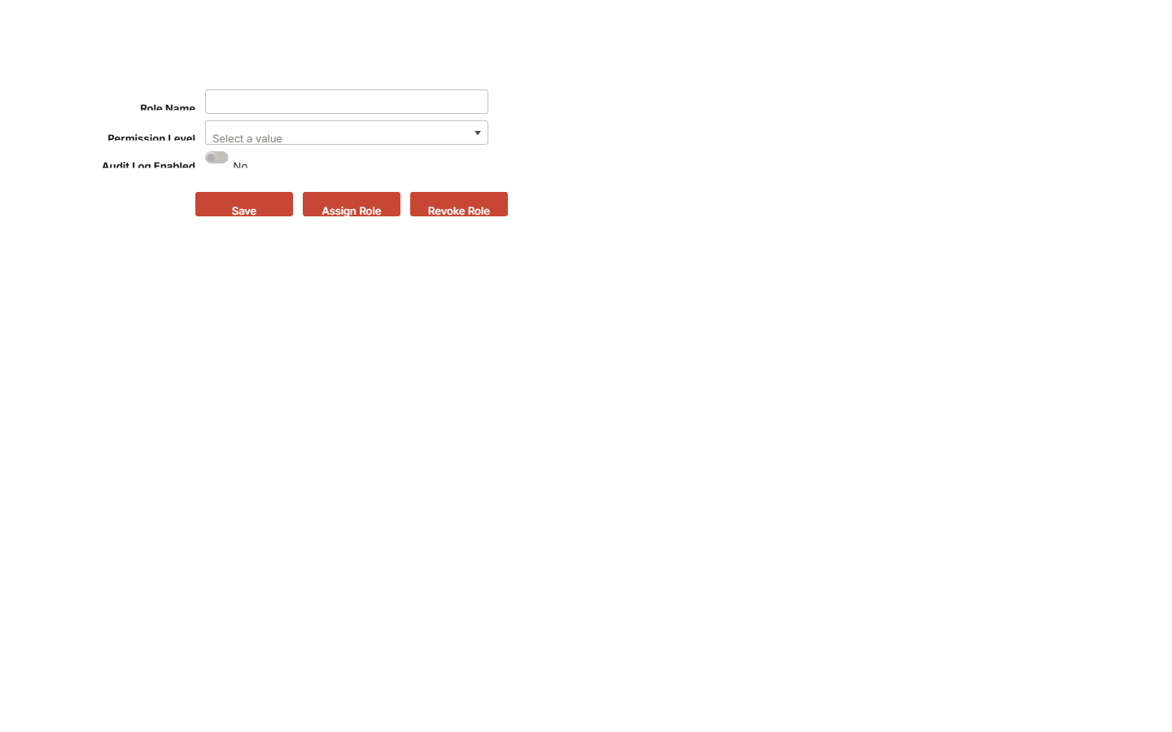

Fields
Field | Type | Required | Values / default | Reference
Role Name | Free text | Yes | — | manage.role_name
Permission Level | Dropdown | Yes | View Only, Edit, Approve, Admin | manage.permission_level
Audit Log Enabled | Yes / No | No | — | manage.audit_log_enabled

Actions
- Save
- Assign Role
- Revoke Role

Behaviour
- Role Name and Permission Level are both mandatory; save is blocked if either is absent.
- Permission Level choices (View Only, Edit, Approve, Admin) must be confirmed as exhaustive — if any business role requires a combination not expressible by a single value, a different control is needed.
- Audit Log Enabled defaults must be confirmed; if audit logging is a compliance requirement it should default to Yes and the toggle should require an elevated permission to change.
- Assign Role opens a user selection step and creates a user-to-role record; the system must record who made the assignment and when.
- Revoke Role removes the user-to-role record; the system must record who performed the revocation, when, and retain the history of the assignment for audit purposes.
- A role that has been assigned to active users should warn before deactivation or deletion, rather than silently removing access.

2.4 Manage Integrations
New page — no existing screen.
Registers external system connections, records their type and endpoint, and provides controls to test, activate and deactivate each connection.
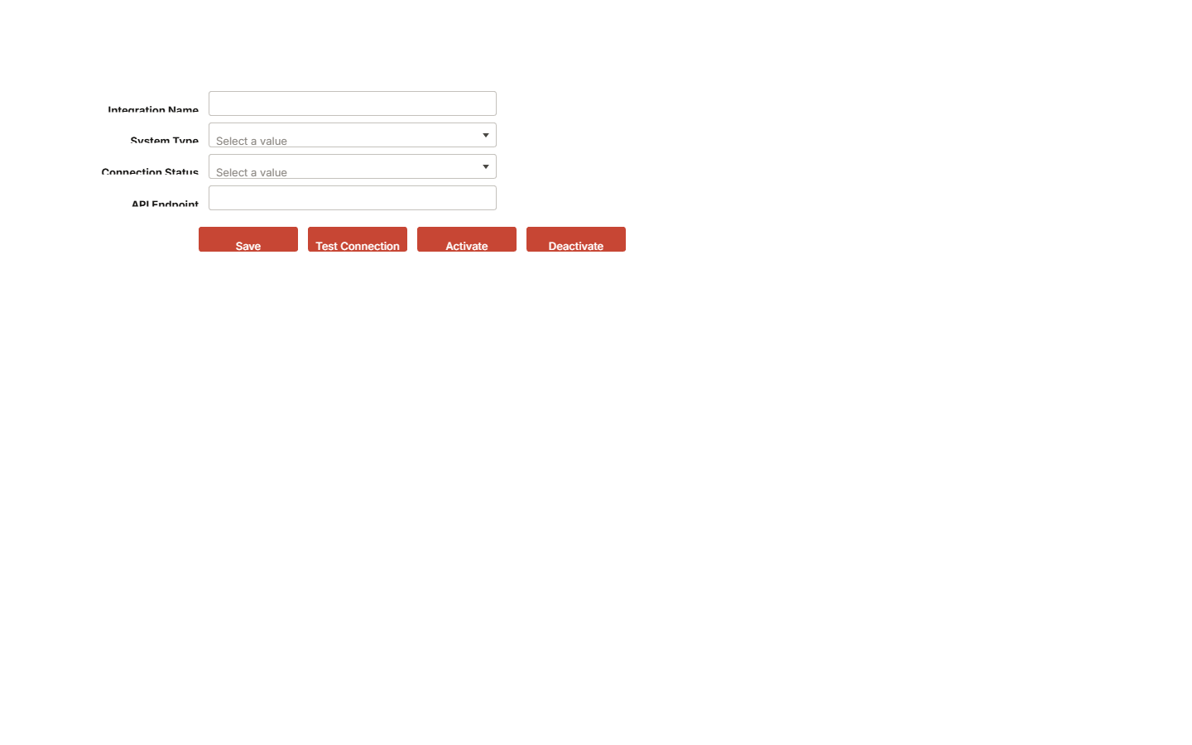

Fields
Field | Type | Required | Values / default | Reference
Integration Name | Free text | Yes | — | manage.integration_name
System Type | Dropdown | Yes | CRM, CPQ, Usage Source, Tax Platform, Payment Platform | manage.system_type
Connection Status | Dropdown | No | Active, Inactive, Error | manage.connection_status
API Endpoint | Free text | No | — | manage.api_endpoint

Actions
- Save
- Test Connection
- Activate
- Deactivate

Behaviour
- Integration Name and System Type are mandatory; save is blocked if either is absent.
- System Type dropdown values (CRM, CPQ, Usage Source, Tax Platform, Payment Platform) must be confirmed as the complete set; if additional system types are anticipated the list must be extensible without code change.
- API Endpoint is optional at creation but should be mandatory before Activate is permitted — the system must validate that an endpoint is present before allowing activation.
- Test Connection executes a live call to the configured endpoint and returns a pass/fail result with error detail; the result must be time-stamped and stored against the integration record.
- Connection Status must reflect the outcome of the last Test Connection or Activate/Deactivate action; it must not be directly editable by users.
- Deactivate stops the integration from sending or receiving data; it must be confirmed whether in-flight messages are queued, discarded or generate an alert.
- Authentication details (credentials, tokens, certificates) are not captured on this screen; where they are stored and how they are referenced by the connection must be defined.

2.5 Manage Invoices
New page — no existing screen.
Creates and manages the full lifecycle of an invoice — from draft through approval, issuance, adjustment and payment — as the single system of record.
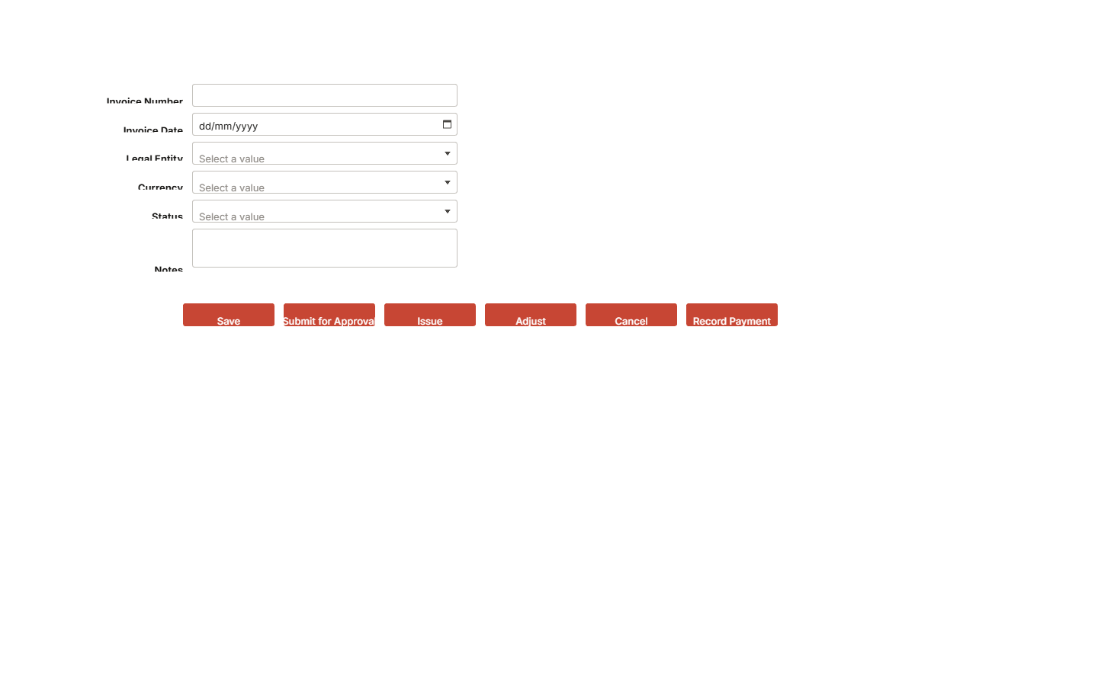

Fields
Field | Type | Required | Values / default | Reference
Invoice Number | Free text | Yes | — | manage.invoice_number
Invoice Date | Date | Yes | — | manage.invoice_date
Legal Entity | Dropdown | Yes | Value A, Value B | manage.legal_entity
Currency | Dropdown | Yes | Value A, Value B | manage.currency
Status | Dropdown | Yes | Draft, Pending Approval, Issued, Adjusted, Cancelled, Paid | manage.status
Notes | Long text | No | — | manage.notes

Actions
- Save
- Submit for Approval
- Issue
- Adjust
- Cancel
- Record Payment

Behaviour
- Invoice Number, Invoice Date, Legal Entity, Currency and Status are all mandatory; save is blocked if any is absent.
- Legal Entity dropdown must be populated from active records in Manage Legal Entities; inactive entities must not appear.
- Currency dropdown must be populated from active records in Manage Currencies; the selected currency determines how amounts are displayed and stored.
- Status on a new record defaults to Draft; the user cannot manually set Status — it must advance only through the action buttons, with the system enforcing permitted transitions.
- Submit for Approval is available only in Draft status; pressing it advances Status to Pending Approval and routes to the configured approval workflow.
- Issue is available only once approval is complete; it advances Status to Issued and triggers downstream processes such as customer delivery and revenue recognition.
- Adjust is available on Issued invoices; it must be confirmed whether pressing Adjust creates a linked credit or debit memo or opens an amendment on the existing record, and what Status the original invoice takes.
- Cancel is available on Draft and Issued invoices; it advances Status to Cancelled and must be confirmed whether a reversing accounting entry is generated automatically.
- Record Payment advances Status to Paid (or Partially Paid if partial payments are supported) and must capture the minimum payment attributes needed for reconciliation — those fields must be specified.
- Notes is optional and free text; it must be confirmed whether notes are visible on the issued invoice document sent to the customer or are internal only.
- All status changes must be recorded in the audit log with user, timestamp and prior status.

3. Field summary
Field | Type | Required | Values / default | Reference
Legal Entity Name | Free text | Yes | — | manage.legal_entity_name
Business Unit | Free text | No | — | manage.business_unit
Intercompany Billing Enabled | Yes / No | No | — | manage.intercompany_billing_enabled
New field | Free text | No | — | manage.new_field
Currency Code | Free text | Yes | — | manage.currency_code
Exchange Rate | Number | Yes | — | manage.exchange_rate
Effective Date | Date | Yes | — | manage.effective_date
Role Name | Free text | Yes | — | manage.role_name
Permission Level | Dropdown | Yes | View Only, Edit, Approve, Admin | manage.permission_level
Audit Log Enabled | Yes / No | No | — | manage.audit_log_enabled
Integration Name | Free text | Yes | — | manage.integration_name
System Type | Dropdown | Yes | CRM, CPQ, Usage Source, Tax Platform, Payment Platform | manage.system_type
Connection Status | Dropdown | No | Active, Inactive, Error | manage.connection_status
API Endpoint | Free text | No | — | manage.api_endpoint
Invoice Number | Free text | Yes | — | manage.invoice_number
Invoice Date | Date | Yes | — | manage.invoice_date
Legal Entity | Dropdown | Yes | Value A, Value B | manage.legal_entity
Currency | Dropdown | Yes | Value A, Value B | manage.currency
Status | Dropdown | Yes | Draft, Pending Approval, Issued, Adjusted, Cancelled, Paid | manage.status
Notes | Long text | No | — | manage.notes

4. System impact — to confirm
Proposed, based on the change shown. Confirm each against the current configuration.
- Legal Entity Name must be confirmed as a unique key — the system must prevent duplicate legal entity records with the same name, and the chosen storage mechanism needs to be confirmed as the authoritative source that downstream objects (invoices, intercompany transactions, consolidation runs) reference.
- The 'New field' on Manage Legal Entities has no name, label or data type — its purpose, storage location and any validation must be defined before build begins.
- Business Unit on Manage Legal Entities is optional free text; if Business Units are a structured entity within Oracle Fusion, this field should resolve against that structure rather than accept arbitrary strings — the approach must be confirmed.
- Intercompany Billing Enabled (Yes/No) implies that when set to Yes, the system generates intercompany billing transactions between entities; the rules governing which entities can bill which, at what transfer price, and how the offsetting entry is created must be specified.
- Activate/Deactivate on Legal Entities must define what deactivation prevents — whether existing invoices referencing that entity are locked, whether new transactions are blocked, and whether the entity remains visible in historical reporting.
- Currency Code is free text and must be confirmed as resolving against Oracle Fusion's ISO currency list; accepting arbitrary strings risks invalid codes reaching invoice and revenue recognition processes.
- Exchange Rate is a single number per currency per effective date — the system must clarify whether this is a spot rate, a monthly average, or a period rate, and which rate type (corporate, user-defined, spot) is applied to which transaction type.
- Update Rate button implies a rate history exists; it must be confirmed that prior rates are retained with their effective dates so that historical invoices are not repriced on rate update.
- Audit Log Enabled on Manage Roles is a per-role toggle; the system must confirm whether disabling audit logging for a role is a supported configuration or whether audit logging is mandatory for all roles for compliance purposes — if mandatory, the toggle should be removed.
- Permission Level is a single dropdown per role; it must be confirmed whether one role can have different permission levels on different objects (e.g. View Only on contracts, Edit on invoices), or whether permission is flat across all billing objects.
- Assign Role and Revoke Role buttons imply a user-to-role assignment step separate from role definition; the screen must expose or navigate to that assignment, and the system must log each assignment and revocation with timestamp and actor.
- Integration records reference an API Endpoint in free text; the system must confirm how credentials, authentication method (OAuth, API key, certificate) and payload schema are stored — API endpoint alone is insufficient to establish a connection.
- Test Connection must return a human-readable result (success, failure reason, latency) and that result must be logged with timestamp so that integration health can be audited.
- Connection Status (Active/Inactive/Error) should be system-set on test or activation, not manually editable, to prevent a user marking a broken connection as Active — this must be confirmed.
- Invoice Number on Manage Invoices is free text and required; it must be confirmed whether the system auto-generates invoice numbers from a sequence, whether manual entry is permitted, and whether uniqueness is enforced globally or per legal entity.
- Legal Entity and Currency dropdowns on Manage Invoices must be populated from the records created in Manage Legal Entities and Manage Currencies respectively — the linkage mechanism must be confirmed.
- Status transitions on invoices must be enforced by the system, not left to user discretion; the permitted transition map (e.g. Draft → Pending Approval → Issued → Adjusted or Cancelled → Paid) must be defined and buttons must be suppressed for invalid transitions.
- Submit for Approval implies a workflow; the approval hierarchy, number of tiers, approver identification (role or named user) and escalation path must be configured before this button can function.
- Adjust and Cancel actions against an already-issued invoice must specify whether a credit memo or reversal transaction is automatically generated, and how the resulting accounting entries are handled in the general ledger.
- Record Payment must capture at minimum payment date, amount, method and reference; it must be confirmed what fields the Record Payment action presents and whether partial payments are supported.

5. Acceptance criteria
- A legal entity record can be created with a name and saved successfully; attempting to save without a Legal Entity Name produces an inline validation error.
- Creating a second legal entity with an identical name is rejected with a duplicate-name error.
- Deactivating a legal entity removes it from the Legal Entity dropdown on Manage Invoices; existing invoices referencing that entity are unaffected.
- A currency record can be created with Currency Code, Exchange Rate and Effective Date and saved; the currency then appears in the Manage Invoices Currency dropdown.
- Invoking Update Rate on an existing currency with a new rate and future effective date creates a new rate record; the previous rate record remains and applies to transactions dated before the new effective date.
- A role can be created with Role Name and Permission Level and saved; the role is then available for assignment to users.
- Assign Role links a user to the role and the assignment is visible with the name of the person who made it and the timestamp.
- Revoke Role removes the user's access and the revocation event is retained in the audit history.
- An integration record saved with System Type 'CRM' and a valid API endpoint can be activated; Connection Status changes to Active.
- Test Connection on an integration with an unreachable endpoint returns a failure result with an error message and does not change Connection Status to Active.
- Deactivating an active integration changes Connection Status to Inactive and prevents further data exchange.
- An invoice cannot be saved without Invoice Number, Invoice Date, Legal Entity, Currency and Status.
- A Draft invoice can be submitted for approval; Status changes to Pending Approval and the approval workflow is triggered.
- An invoice in Pending Approval cannot be issued until approval is granted; the Issue button is suppressed or disabled.
- An Issued invoice can be cancelled; Status changes to Cancelled and any required reversing entry is generated.
- Record Payment on an Issued invoice advances Status to Paid and records the payment event in the invoice audit trail.
- All status transitions on an invoice are recorded in the audit log with the acting user's identity and a timestamp.
- The Audit Log Enabled toggle on a role, when set to No (if permitted), results in no audit entries being written for actions performed by users in that role — or, if audit logging is mandatory, the toggle is not present and all actions are always logged.

6. Assumptions
- Oracle Fusion's native legal entity and business unit framework is the target configuration layer for Manage Legal Entities; no custom tables are being built to shadow that framework.
- Exchange rates entered in Manage Currencies are intended to feed Oracle Fusion's rate type configuration; the specific rate type (corporate, spot, user-defined) to be used for billing transactions has been assumed to be a single type pending confirmation.
- The four Permission Level values (View Only, Edit, Approve, Admin) are assumed to map to Oracle Fusion's role and privilege model without requiring custom permission objects.
- Approval workflows referenced by Submit for Approval on invoices are assumed to be configured within Oracle Fusion's approval management framework, not in an external tool.
- The Legal Entity and Currency dropdowns on Manage Invoices are assumed to be driven dynamically from the active records in their respective setup screens, not from a static list.
- Invoice Number is assumed to require uniqueness enforced at the legal entity level; global uniqueness has not been assumed.
- All five integration types (CRM, CPQ, Usage Source, Tax Platform, Payment Platform) are assumed to be reachable via API; no file-based or batch integration method has been assumed.
- The 'New field' on Manage Legal Entities is assumed to be a placeholder that will be named and specified before build; it has not been treated as a defined requirement.

7. Open questions
- Requirement 1.1 states the system must run natively inside the ERP — it is not confirmed which ERP platform is in scope, which will determine whether this is achievable and what 'native' means in practice.
- Requirement 1.4 mentions approval controls but does not specify what objects require approval (e.g. invoices, credit memos, contract amendments), what the approval hierarchy looks like, or how many approval tiers are needed.
- Requirement 1.5 lists integration targets (CRM, CPQ, usage sources, tax, payments) but does not name the specific systems, so the integration method (API, native connector, middleware) and data flow direction remain undefined.
- Requirement 1.6 states the system must support future changes to pricing, billing or revenue models without reimplementation, but gives no detail on what configuration mechanisms are expected (e.g. rule builders, scripting, no-code tools).
- Exchange rate management (Req 1.3) does not specify whether rates should be manually entered, pulled automatically from a feed, or both, nor how often they should be updated.
- Audit log requirements (Req 1.4) do not specify retention period, who can view logs, or whether logs must be exportable for external audit purposes.
- The 'New field' on Manage Legal Entities has no name, data type or purpose — what is this field, what does it store, and is it mandatory? Until this is answered the screen cannot be fully built.
- Business Unit on Manage Legal Entities is free text, but Oracle Fusion has a structured Business Unit entity — should this field resolve against existing Business Units in the platform rather than accepting arbitrary strings? If so, the control should be a searchable lookup, not free text.
- Intercompany Billing Enabled is a Yes/No toggle, but enabling intercompany billing typically requires rules about which entities can transact, at what transfer price, and with what accounting treatment — where are those rules configured, and does toggling this field trigger that setup or simply flag intent?
- Is audit logging per role (as the Audit Log Enabled toggle implies) a supported compliance position, or must all actions by all roles be logged unconditionally? If the latter, the toggle should be removed to avoid a false impression of configurability.
- Permission Level is a single value per role — does any user group require different access levels on different objects (for example, Edit on invoices but View Only on contracts)? If so, a flat per-role permission level is insufficient and the model needs to be redesigned.
- What fields does the Record Payment action present — at minimum, payment date, amount, currency and reference are expected — and are partial payments against a single invoice supported?
- Is the Notes field on Manage Invoices internal only, or does it print on the invoice document sent to the customer?
- What is the permitted status transition map for invoices — specifically, can a Cancelled invoice be reopened, can an Adjusted invoice be cancelled, and what status does the original invoice carry when an adjustment is in progress?
- For integrations, where are authentication credentials (API keys, OAuth tokens, certificates) stored, and how does the connection reference them — the API Endpoint field alone is not sufficient to establish a secure connection?
- Does the System Type dropdown on Manage Integrations need to be extensible by administrators without a code change, or is the five-value list fixed for the foreseeable future?
- What happens to in-flight messages when an active integration is deactivated — are they queued, discarded or flagged for manual resolution?

Background, behaviour, acceptance criteria, assumptions, and open questions were drafted by AI from the screens and notes. Review before circulating. Screens, fields, and navigation are taken directly from the mockup.

